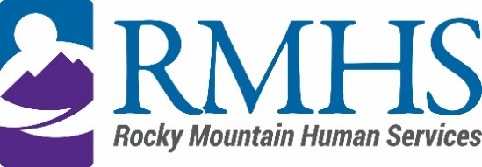

Community Advisory Council Meeting Minutes
May 16, 2023

Members Present: | Pam Bisceglia, Chair  Michelle Dumay, Member  and DHS Liaison  Maeline Barnstable, Member  Cristina Gomez, Member  Benny Mudliar, Member | Staff: | Georgia Edson, CPO  Dana Johnson, Executive Assistant  Abby Grinstead, Mill Levy Associate Director  Kizzly Blue, Program Manager
Members Absent: | Lynette Johnson, Member  Faith Vidrine, Member | Guests: | Lynn Kutner, DHS

Pam Bisceglia, Community Advisory Council Chair called the meeting to order at 3:36 pm via Microsoft Teams.

Introductions
Pam Bisceglia gave a brief welcome and read the mission and goals of the CAC to members, staff, and guests. The guests held a warm icebreaker.

Review and Approval of minutes
The Council reviewed March’s minutes. Maeline Barnstable moved to approve the March minutes. Michelle Dumay seconded and was passed by a unanimous vote.

IDDEAS AD-CO
The council went through the procedural process to change quorum needs. Temporarily changed from 5 to 3. There have not been any meetings since CAC last met.

RMHS Updates
The council discussed the need to move public comment to an earlier time, approximately 4pm.

External Initiatives
The council will need to review the process and potentially make changes. Review includes the current process for applications for CY2024 wherein current steps, priority areas for CY23 and updated terms wherein reviewed wherein external initiatives will be on a 3-year contract.

Furthermore, the council reviewed referred ways of receiving information, judging rubrics and consensus goals to approve, deny or ask additional questions. Future goals include getting in depth about the process and how we want to do it moving forward.

RMHS Updates
Client Family request year to date
Requests are trending high with individual requests with an almost 3k request approval rate. The council reviewed individual stories and identified that requests are tracked by zip code and council districts.

Case Management Agency Update
Contract rollout will start in January, with more rollout phases in February and July 2024.
RMHS will continue to be CCB and SEP and mill levy will stay in Denver.

Future meeting forecast
The council discussed the desire for a potentially hybrid meeting in June with one part being public, the other part a closed session.

Public Comment
There was no public comment.

CAC Announcements
The council announced many upcoming events including:
May 21 is the autism community fair; Philippine Festival is June 11 & 12th. CPR classes offered to the public will be hosted by Benny.

Adjournment
The meeting adjourned at approximately 5:12 pm.

Next Meeting
The next Community Advisory Council meeting will be held June 20, 2023 via Microsoft Teams.

