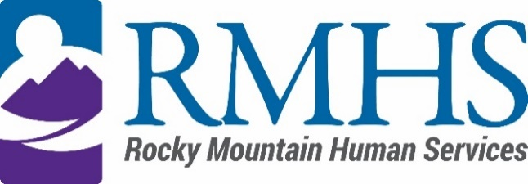

Community Advisory Council Meeting
February 21, 2023

Agenda
The February meeting will be accessible online only. You are invited to attend using the information listed below.
Click here to join the meeting
+1 720-372-0556,,783835096# United States, Denver
Phone Conference ID: 783 835 096#

The Mission of the Community Advisory Council is to make informed recommendations that reflect transparency and drive transformation of the culture and community to be inclusive of people of all abilities and backgrounds.

Community Advisory Council Goals:
- Identify and forward recommendations that encourage and expand children and adults' abilities and gifts.
- Identify and recruit diverse membership (social and economic, racial or ethnic, disability, gender, sexual orientation).
- Identify the values and priorities that guide mill levy expenditures.

3:30 pm | Welcome | Introductions & Ice Breaker
3:40 pm | RMHS Mill Levy Staff Roles/Responsibliites | Georgia Edson
3:50 pm
  Update on External Iniatives
  Kizzly Blue
4:00 pm | IDDEAS Advisory Council Update | Michelle Dumay
4:15 pm | Community Advisory Committee  - Membership/recruitiment  - Virtual and/or in person meetings | Pamela Bisceglia
4:30 pm | Case Management update  - SIS  - Care and Case Management System  - CMA | Georgia Edson and Pamela Bisceglia
5:00 pm | RMHS technology update | Abby Grinstead
5:15 pm | Public Comment

To request translation services or any additional accommodations, contact

Dana Johnson

720-467-3538

djohnson@rmhumanservices.org

