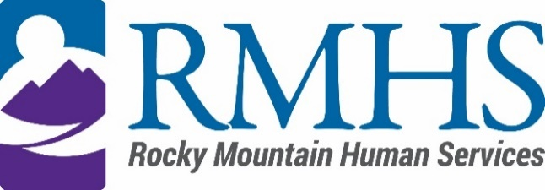

Community Advisory Council Meeting
March 21, 2023

Agenda
The March meeting will be accessible online only. You are invited to attend using the information listed below.
Click here to join the meeting
+1 720-372-0556,783835096# United States, Denver
Phone Conference ID: 783 835 096#

The Mission of the Community Advisory Council is to make informed recommendations that reflect transparency and drive transformation of the culture and community to be inclusive of people of all abilities and backgrounds.

Community Advisory Council Goals:
- Identify and forward recommendations that encourage and expand children and adults' abilities and gifts.
- Identify and recruit diverse membership (social and economic, racial or ethnic, disability, gender, sexual orientation).
- Identify the values and priorities that guide mill levy expenditures.

3:30 pm | Welcome | Introductions & Ice Breaker
3:40 pm | February Minutes | Pamela Bisceglia
3:45 pm
  Update on External Iniatives
  Kizzly Blue
4:00 pm | IDDEAS Advisory Council Update | Michelle Dumay
4:15 pm | RMHS updates  - Single Entry Point  - Conflict Free Case Management  - Part C | Georgia Edson
5:00 pm | How to talk to people wbout what a CMA will look like | Georgia Edson
5:15 pm | Public Comment | Georgia Edson
5:25 pm | Announcements | All

To request translation services or any additional accommodations, contact

Dana Johnson

720-467-3538

djohnson@rmhumanservices.org

