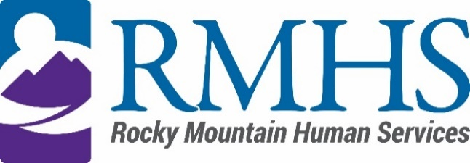

Community Advisory Council Meeting
May 16, 2023

Agenda
The May meeting will be hybrid. You are invited to attend in person in the boardroom or by using the information listed below.
Click here to join the meeting
+1 720-372-0556,783835096# United States, Denver
Phone Conference ID: 783 835 096#

The Mission of the Community Advisory Council is to make informed recommendations that reflect transparency and drive transformation of the culture and community to be inclusive of people of all abilities and backgrounds.

Community Advisory Council Goals:
- Identify and forward recommendations that encourage and expand children and adults' abilities and gifts.
- Identify and recruit diverse membership (social and economic, racial or ethnic, disability, gender, sexual orientation).
- Identify the values and priorities that guide mill levy expenditures.

3:30 pm | Welcome | Introductions & Ice Breaker
3:40 pm | March Minutes (April meeting cancelled) | Pamela Bisceglia
3:45 pm
  IDDEAS Advisory Council Update
  Michelle Dumay
4:00 pm | Public Comment | Pamela Bisceglia
4:15 pm | External project request for proposal (RFP) process review | Kizzly BLue
4:25 pm | Client/Family request year to date | Abby Grinstead
4:40 pm | Case Mangement Agency update | Georgia Edson
5:00 pm | Future meeting forecast | Pamela Bisceglia
5:20 pm | Announcements | All members

To request translation services or any additional accommodations, contact

Dana Johnson

720-467-3538

djohnson@rmhumanservices.org

