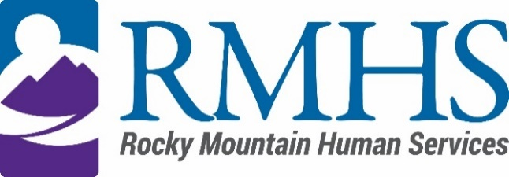

Community Advisory Council Meeting
September 19, 2023

Agenda
The September meeting will be accessible online only. You are invited to attend using the information listed below.
Click here to join the meeting
+1 720-372-0556,783835096# United States, Denver
Phone Conference ID: 783 835 096#
The Mission of the Community Advisory Council is to make informed recommendations that reflect transparency and drive transformation of the culture and community to be inclusive of people of all abilities and backgrounds.
Community Advisory Council Goals:
- Identify and forward recommendations that encourage and expand children and adults' abilities and gifts.
- Identify and recruit diverse membership (social and economic, racial or ethnic, disability, gender, sexual orientation).
- Identify the values and priorities that guide mill levy expenditures.

3:30 pm | Welcome | Introductions & Ice Breaker
3:40 pm | August Minutes | Pamela Bisceglia
3:45 pm |  | Pamela Bisceglia
  Council chair nominations and elections
4:10 pm | IDDEAS Advisory Council Update | Michelle Dumay
4:20 pm | Community Initiative presentation- Therapies for Hope | Eric Victor
4:45 pm | Public Comment | All
5:00 pm | Update Case Management Agency Contract | Georgia Edson
5:20 pm | Future meeting location | All
5:25 pm | Announcements | All

To request translation services or any additional accommodations, contact

Dana Johnson

720-467-3538

djohnson@rmhumanservices.org

