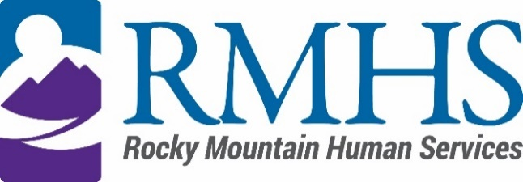

Community Advisory Council Meeting
August 15th, 2023

Agenda
The August meeting will be held via Teams using the information listed below.
Click here to join the meeting
+1 720-372-0556,783835096# United States, Denver
Phone Conference ID: 783 835 096#

The Mission of the Community Advisory Council is to make informed recommendations that reflect transparency and drive transformation of the culture and community to be inclusive of people of all abilities and backgrounds.

Community Advisory Council Goals:
- Identify and forward recommendations that encourage and expand children and adults' abilities and gifts.
- Identify and recruit diverse membership (social and economic, racial or ethnic, disability, gender, sexual orientation).
- Identify the values and priorities that guide mill levy expenditures.

3:30 pm | Welcome | Introductions & Ice Breaker
3:40 pm | June Minutes | Pamela Bisceglia
3:45 pm
  IDDEAS Advisory Council Update
  Michelle Dumay
4:00 pm | Public Comment | Pamela Bisceglia
4:30 pm | Evoke-Community initiative presentation | Kizzly Blue-Intro Emily
5:00 pm | Elections/recruitment | Pamela Bisceglia
5:25 pm | Announcements | All

To request translation services or any additional accommodations, contact

Dana Johnson

720-467-3538

djohnson@rmhumanservices.org

