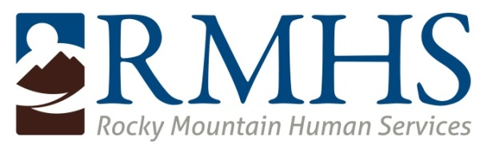

BOARD OF DIRECTORS MEETING
May 16, 2018
Agenda

The RMHS Board will convene at 5:30 pm and is expected to immediately move to executive session.

The RMHS Board meeting will begin at 6:30 p.m. and is open to the public.

If you’re unable to attend the Board Meeting in person, you can also join the meeting by calling our

General Conference Line:

1-888-387-8686.

Participant Passcode: 2939136#.

Welcome & Introductions (Mark Ferrandino) 6:30 PM

Consent Agenda (Mark Ferrandino)
- Approval of May Agenda
- Adoption of March 21, 2018 Board Minutes
Proposed Board Resolution: The Board accepts the items on the Consent Agenda.

Community Advisory Council Report (Chair, Pam Bisceglia) 6:40 PM

President’s Report (Mark Ferrandino ) 6:50 PM
- Safety Committee Update (Jose Torres-Vega, Olga Feldman, Nisa’a Ameen-Abdullah)
- Nominating Committee Report (Lloyd Lewis & Amy Ross)
  - Community Advisory Council
- Foundation Report

Executive Director’s Report (Shari Repinski) 7:00 PM
- Organizational Update
  - Momentum (Ford Allison)
- Mill Levy Update
- Legislative Update

Public Comment Period 7:15 PM

Finance Committee Report (Bill Ojile & John Wetherington) 7:30 PM
- YTD Report
Proposed Board Resolution: The Board accepts the YTD report.
- Planning Calendar

Compliance Update (John Wetherington) 7:40 PM

New Business/Announcements 7:50 PM

Adjournment 8:00 PM

