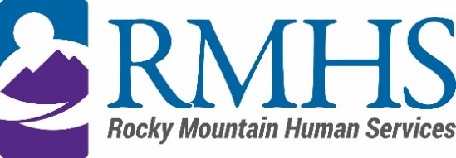

Community Advisory Council Meeting Minutes
January 16, 2024

Members Present: | Maeline Barnstable, Chairperson  Michelle Dumay, Member  and DHS Liaison  Cristine Gomez, Member | Staff: | Georgia Edson, CPO  Dana Johnson, Executive Assistant  Kizzly Blue, Program Manager
Members Absent: | Benny Mudliar, Member | Guests: | Lynn Kutner, DHS

Maeline Barnstable, Community Advisory Council Chair, called the meeting to order at 3:33 pm via Microsoft Teams.

Introductions
Maeline Barnstable gave a brief welcome and read the mission and goals of the CAC to members, staff, and guests. The guests held a warm icebreaker.

Review and Approval of minutes
The council reviewed the October 17, 2023 minutes. Michelle motioned to approve the minutes. Maeline Barnstable seconded.

IDDEAS AD-CO
Michelle Dumay reported an update to the council.

https://denver.prelive.opencities.com/Government/Agencies-Departments-Offices/Agencies-Departments-Offices-Directory/Denver-Human-Services/Events/2021/IDDEAS-Advisory-Council

Mill Levy Department
Abby Grinstead, Mill Levy Associate Director, provided updates for the new 4-year, $108M mill levy contract through DHS. Further updates include external initiatives and the process for expired external initiative contracts.
Other RMHS announcements include the welcoming back of a previous RMHS staff person as the new internal program manager, Emily Mower.

Home Modification
Abby refreshed the need to housing stability for members and the question of if home modification should be on a case-by-case basis or if there should be a set of parameters for reviewing requests. The modifications are expensive and renters in Denver already have difficulties with housing stability.

Abby reiterated that RMHS only works with contractors who have experience with waiver services so that we can consistently provide middle of the road services.

The committee discussed the need to have a rubric or set process for how we go through the guideline setup for home modifications. Further needs include piloting the potential for a year to see what mods we get requested and what the typical timeline looks like.

CAC Announcements
The committee discussed ways to increase participation and recruitment including offering compensation, visuals fliers of responsibilities, goals.

Public Comment
There was no public comment.

Adjournment
The meeting adjourned at approximately 4:58 pm.

Next Meeting
The next Community Advisory Council meeting will be held February 14, 2024 via Microsoft Teams.

