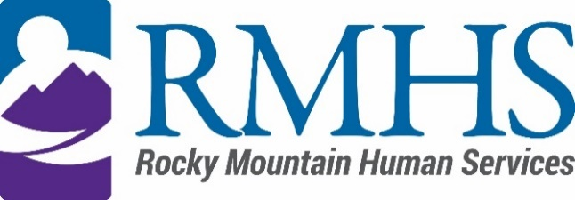

Community Advisory Council Meeting
September 20, 2022

Agenda
The February meeting will be accessible online only. You are invited to attend using the information listed below.
Join Microsoft Teams Meeting
+1 720-372-0556 United States, Denver (Toll)
Conference ID: 719 986 01#

The Mission of the Community Advisory Council is to make informed recommendations that reflect transparency and drive transformation of the culture and community to be inclusive of people of all abilities and backgrounds.

Community Advisory Council Goals:
- Identify and forward recommendations that encourage and expand children and adults' abilities and gifts.
- Identify and recruit diverse membership (social and economic, racial or ethnic, disability, gender, sexual orientation).
- Identify the values and priorities that guide mill levy expenditures.

3:30 pm | Welcome | Introductions & Ice Breaker
3:40 pm | Decision | Review and approve funding priority recommendations
3:45 pm | RMHS Mill Levy Update | Amy Becerra
3:55 pm | IDDEAS Advisory Council Update | Michelle Dumay
4:05 pm | Public Comment
4:15 pm | Closed Session – 2022 Community Initiatives Contract Performance Review | Amy Becerra

To request translation services or any additional accommodations, contact

Dana Johnson

720-467-3538

djohnson@rmhumanservices.org

