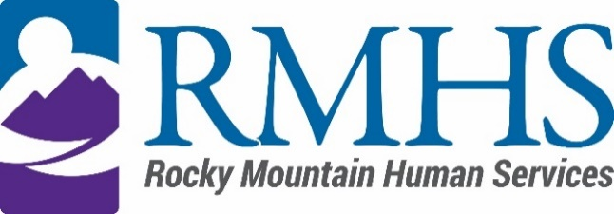

Community Advisory Council Meeting
January 16th, 2024

Agenda
The January meeting will be accessible online only. You are invited to attend using the information listed below.
Click here to join the meeting
+1 720-372-0556,783835096# United States, Denver
Phone Conference ID: 783 835 096#
The Mission of the Community Advisory Council is to make informed recommendations that reflect transparency and drive transformation of the culture and community to be inclusive of people of all abilities and backgrounds.
Community Advisory Council Goals:
- Identify and forward recommendations that encourage and expand children and adults' abilities and gifts.
- Identify and recruit diverse membership (social and economic, racial or ethnic, disability, gender, sexual orientation).
- Identify the values and priorities that guide mill levy expenditures.

3:30 pm | Welcome |  | Introductions & Ice Breaker
3:40 pm | October Minutes |  | Maeline Barnstable
3:45 pm
  IDDEAS Advisory Council Update
  Michelle Dumay
3:55 pm | Update RMHS Community Initiative 2024 |  | Kizzly Blue
4:15 pm | Public Comment |  | All
4:30 pm | CAC recommendation-home modification follow up |  | Maeline Barnstable
5:00 pm |  | Announcements

To request translation services or any additional accommodations, contact

Dana Johnson

720-467-3538

djohnson@rmhumanservices.org

