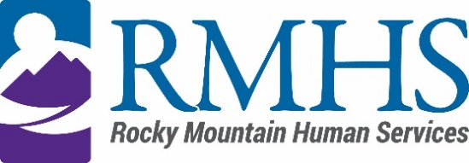

Mill Levy Community Advisory Council Meeting Minutes
October 21, 2025

Members Present: | Maeline Barnstable, Chairperson  Michelle Dumay, Member  Tinsley Ore, Member  Lynn Kutner, DHS Liaison  Corinne DePersis, Member  Alfredo Jesus Bonilla Flores, Member  Molly Mason, Member and DHS liaison | Staff: | Dana Johnson, Executive Assistant  Abby Grinstead, Mill Levy Associate Director  Jodi Litfin  Erik Easley, ML Program Manager  Mariam Alami, START Associate Director  Ernie Swenson, Mission Supports Associate Director
Members Absent: | Benny Mudliar, Member  Schuyler Kropp, Member  Jennifer Gilbert, Member  Cristine Gomez, Member | Guests:

Maeline Barnstable, Community Advisory Council Chair, called the meeting to order at 4:05 pm via Microsoft Teams.

Introductions
Maeline Barnstable gave a brief welcome and read the mission and goals of the CAC to members, staff, and guests. The attendees then held a warm icebreaker.

Minutes
The council reviewed the August 19, 2025 minutes. The minutes approval was moved by Tinsley Ore and seconded by Alfredo Bonillo-Flores.

IDDEAS AD-CO
Molly Mason reported an update to the council.

https://denver.prelive.opencities.com/Government/Agencies-Departments-Offices/Agencies-Departments-Offices-Directory/Denver-Human-Services/Events/2021/IDDEAS-Advisory-Council

School Savvy
Kate Silverman, founder of School Savvy, presented her work as an educational consultant supporting families with children receiving services through RMHS. She detailed how School Savvy helps families navigate school choices, special education, and transitions. The initiative has served 224 families since February and focuses on preschool through 8th grade in the Denver metro area.

Community Initiative
The council discussed expanding services through targeted RFPs and strategic partnerships. Plans are underway to transition to a new space in Q1 2026, with recommendations and a launch expected early next year. Operational mechanics are still being refined, and budget implications were considered. START services were introduced, and Maeline will follow up via email regarding a potential in-person meeting in November.

CAC Announcements
Announcements included updates on the Sensory House (contact Tinsley tinsley@inclusivedenver.org) and that there will be an upcoming IDEAS AD CO meeting.

Public Comment
There was no public comment.

Adjournment
The meeting adjourned at approximately 5:58 pm.

Next Meeting
The next Mill Levy Community Advisory Council meeting will be held November 11, 2025 via Microsoft Teams.

