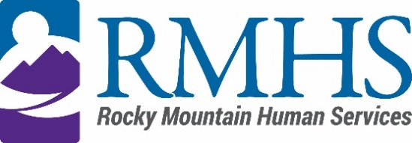

CMA Advisory Council Meeting Minutes
May 13, 2025

Members Present: | April Prahst  Shadia Ahmad  Damian Rosenburg  Sam Newren  Jaime Rodriguez  Romaine Etor Akakpo  Ty Smith  Jose Torres-Vega  Sara Bohar | Staff: | Dana Johnson, Executive Assistant  Melissa Emery, CMA Director
Members Absent: | Josh Wann  Julia Reiskin  Kari Easterly | Guests:

Melissa Emery called the meeting to order at 3:35 pm via Microsoft Teams.

Introduction
Melissa Emery gave a brief welcome to the attendees then held a warm icebreaker.

Minutes
Ty Smith made a motion to accept the minutes from February 21, 2025, it was accepted by a unanimous voice vote. Minutes are approved.

RMHS website review
The committee reviewed names/titles on the RMHS Case Management Agency Community Advisory Council website. Those interested in putting our photos on the website are asked to send their headshots to Dana at DJohnson@rmhumanservices.org.

Complaint/escalation process
Melissa presented how to find and fill out the complaint process from our website. Another popular option is to have a case manager submit a complaint on behalf of the client. The committee reviewed the process and what to expect once they’ve submitted a complaint. There is a quarterly complaint trend analysis reporting log, and there are resolution managers who review/ensure the complaints are being addressed. There are procedures that are provided for staff that show them how to address complaints and how to resolve them.

The committee reviewed other options to file or address a complaint, including various methods including phone calls, emails, in person, offering the form in more languages and making the link to the form more easily seen on the RMHS website. Discussions included potential tasks for the council including follow-ups and quality control after a complaint has been resolved. Further clarification of timelines and examples of types of complaints is needed to understand the data more clearly and address trends.

Complaint/escalation data review
The committee reviewed data that was compiled from complaints filed by clients. Most issues arise from the process of enrolling into programs because the process is hard enough without the hiccups that can happen.

CAC member topics and public comment
The committee would like to review CMA acronyms and subsequent language with Melissa at the next meeting.

Adjournment
The meeting adjourned at approximately 5:37 pm.

Next Meeting
The next Community Advisory Council meeting will be held on August 12, 2025 via Microsoft Teams.

