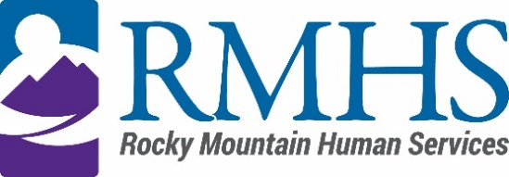

Mill Levy Community Advisory Council Meeting Minutes
August 19, 2025

Members Present: | Maeline Barnstable, Chairperson  Molly Mason, Member and DHS liaison  Michelle Dumay, Member  Benny Mudliar, Member  Tinsley Ore, Member  Jennifer Gilbert, Member  Lynn Kutner  Alfredo Jesus Bonilla Flores, Member  Cristine Gomez, Member  Schuyler Kropp, Member  Corinne DePersis, Member | Staff: | Dana Johnson, Executive Assistant  Kizzly Blue, Program Manager  Abby Grinstead, Mill Levy Associate Director  Jodi Litfin  Lindsey Lambert
Members Absent: |  | Guests:

Maeline Barnstable, Community Advisory Council Chair, called the meeting to order at 4:00 pm via Microsoft Teams.

Introductions
Maeline Barnstable gave a brief welcome and read the mission and goals of the CAC to members, staff, and guests. The attendees then held a warm icebreaker.

Minutes
The council reviewed the June 17, 2025 minutes. The ratified minutes approval was moved by Michelle Dumay and seconded by Alfredo Bonillo-Flores.

IDDEAS AD-CO
Molly Mason reported an update to the council.

https://denver.prelive.opencities.com/Government/Agencies-Departments-Offices/Agencies-Departments-Offices-Directory/Denver-Human-Services/Events/2021/IDDEAS-Advisory-Council

Gym Guys
Barb Garey from Gym Guyz presented their initiative to support individuals with intellectual and developmental disabilities (IDD) through in-home personal training. The program currently serves 19 clients and includes adaptive fitness certifications, personalized fitness and nutrition plans, and progress assessments. The goal is to expand to 50 clients and include bilingual trainers.

Community Forum
The council discussed the upcoming community forum titled “Getting Started: Navigating,” scheduled for October 8 (in-person at Lowry Conference Center) and October 15 (virtual). The event will feature an “Ask Me Anything” panel and a resource fair. Abby Grinstead asked if the council would like to host a Mill Levy booth. Cristina Gomez volunteered for the in-person event, and Maeline Barnstable for the virtual one. The forum will also highlight improvements to the SLS waiver.

CAC Announcements
School resource guide:

https://www.rmhumanservices.org/news/colorado-back-to-school-guide/

Public Comment
There was no public comment.

Adjournment
The meeting adjourned at approximately 5:50 pm.

Next Meeting
The next Mill Levy Community Advisory Council meeting will be held October 21, 2025 via Microsoft Teams.

