Instructions for Community Initiatives Proposal Application

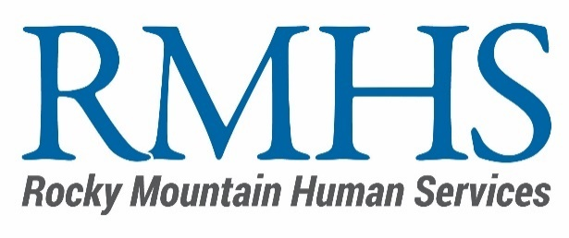

Applicants must submit their proposal through a link to Microsoft Forms. The application does not have a “save progress” feature you will need to complete the form in one session. We suggest populating your responses ahead of time and copying them into the form. Please provide clear and concise responses.
Mill Levy Program

The Funding Announcement includes a budget template along with detailed instructions to guide applicants in completing this section of the application.

Application for Denver Mill Levy Community Initiative Rolling Funding

Section 1: Before You Begin
- Have you reviewed the Community Initiative Application, and do you understand the funding requirements?
- Does your organization currently receive mill levy funding from RMHS or another IDDEAS funding source? If yes to Question 2, please specify the funder and a 1-2 sentence description of the project.
- Has your organization received mill levy funding from RMHS or another IDDEAS funding in the past? If "Yes" to Question 4, please specify the funder, year(s) of funding and project name.

Section 2: Organization Information
- Organization Name
- Primary Contact's Name, Title, Email, and Phone
- Additional Contact’s Name, Title, Email, and Phone
- Confirm Organization's Tax ID/Employer Identification Number (EIN)
- Introduction to your Organization. Tell us about your organization, why your organization is leading the proposed work, and your vision for this work. If you are launching a new program, describe your organization’s experience with implementing new programs.

Section 3: Project/Program Proposal Information
- Project Title and Brief Summary
- Is this project/program a new program, a continuation of an existing program, or an expansion of an existing program?
- If this is a continuation or expansion of an existing program, describe your existing revenue sources for this program.
- If this is a continuation or expansion of an existing program, what outcomes or results have you seen so far?
- Mill Levy funds cannot be used to supplant or replace existing federal, state, city, and/or other local agency funds. However, funds may be used to supplement existing funds to enhance or expand service offerings. Do you currently receive federal, state, City of Denver, or other local agency funds for this work? If yes, explain how Mill Levy funds will be used to supplement (not supplant) existing funds
- Geographic Areas Served – Use this tool to locate the Denver City Council districts you serve at https://www.denvergov.org/maps/map/councildistricts. This needs to reflect the geographic areas served, not where your office is located. Select one or more. If you serve the entire city, select Denver Citywide and no other districts. If you primarily serve specific districts, select those districts and not Denver Citywide.
- Indicate if your project meets a priority funding area(s)
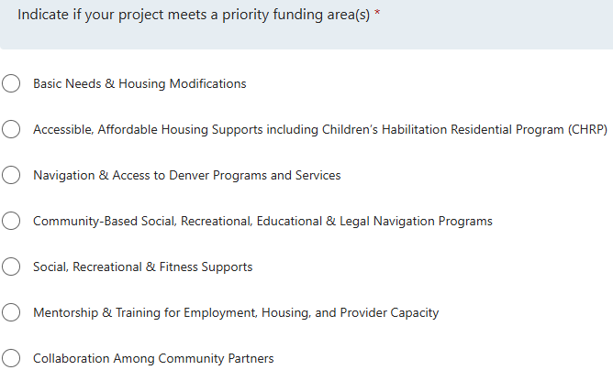

- Brief Need Statement - In 1-2 sentences, tell us the specific issue or problem your project/program will address related to focus area and/or priority funding area you chose.
- The Problem - Why is this an important project/program for mill levy investment to benefit Denver residents with IDD? This is an opportunity to expand the Brief Need Statement above.
- What age does the project/program intend to serve?
- How many individuals does this project have the capacity to serve - Please provide the projected number of unduplicated eligible Denver residents to be served by the program/project for the requested funding.
- Population Served - Describe the people or community your proposal will serve. How does your organization reflect the culture of the community you intend to serve? How does your organization ensure that the direct services and/or activities proposed are relevant to the needs of the community? You may include socioeconomic, demographic, or any other information that you think is important.
- Project/Program Description - Describe the specific actions or strategies you intend to carry out with mill levy funding to help address the need described above. Focus on describing your project/program’s intended activities and how you will use the requested funds rather than describing the need for the project/program or an organizational summary. Please be clear about how your actions or strategies will address the need and benefit Denver residents with IDD.
- Intended Outcomes - What changes and/or outcomes do you hope to see from implementing your project/program? Describe what success would look like for your project/program.
- Measuring Progress and Outcomes - Considering the activities and intended changes described above, what do you think would be important to evaluate/measure to help you and the RMHS Mill Levy Program understand your program’s progress and impact? We encourage you to think about measures that feel valuable to your organization. If you are awarded a grant, we will work together to finalize a scope of work, establish intended outcomes, and determine what qualitative and quantitative measures will be most meaningful for you to include as part of your reporting requirements.
- Challenges - What challenge do you think you might face as you implement the project/program? What risks might you encounter that could impact intended outcomes?

Section 4: Commitment to Equity, Access, and Community Voice
- Accessibility - Please describe how the project/program will ensure access to eligible Denver residents. What steps have you taken to identify and eliminate potential barriers that may prevent full program participation. Examples included, but are not limited to transportation, remote participation options, and adaptations or tools necessary for participation.
- RMHS is committed to funding and supporting innovative efforts that move our community towards equity and outcomes where race, ethnicity, disability, immigration status, and identity no longer predict life outcomes. Please describe how your project/program is committed to ensuring opportunities are visible, approachable, and accessible to all eligible Denver residents?

Section 5: Budget Narrative and Template
- Please refer to the Budget Instructions included in the announcement.

Section 6: Before You Go
- Would you like to provide a link to media content (YouTube, Facebook, TikTok, your website, etc.) about the proposed project/program? (NOT REQUIRED)
- Is there anything else you would like us to know that was not addressed in other questions? (NOT REQUIRED)

