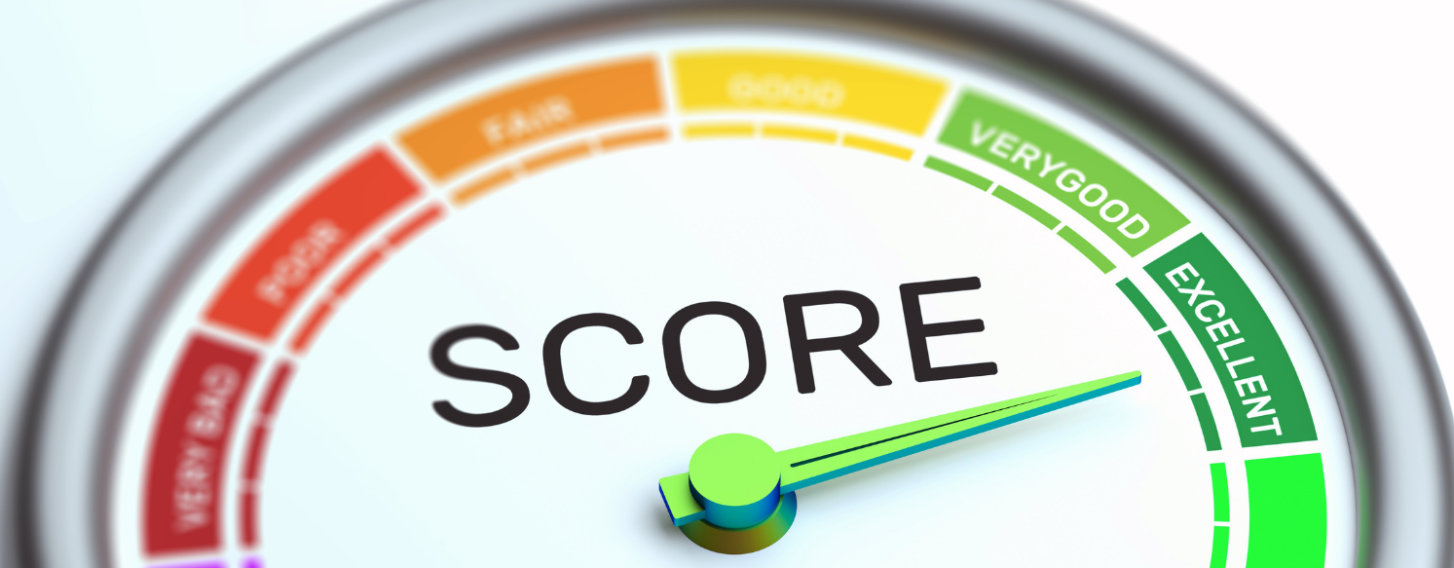
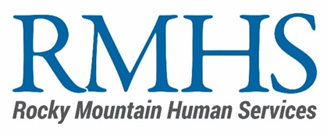
Community Initiative
Minimum Criteria & Scoring Rubric
Mill Levy Program
Minimum Criteria

- Did the applicant meet the minimum criteria to move forward in the review process?
- The applicant completed the online application.
- The applicant submitted the Line-Item Budget Template to the Mill Levy Inbox

Objective Review

RMHS utilizes a transparent and standardized scoring process to evaluate all proposals submitted for Mill Levy funding. Proposals may receive up to 100 total points, based on the following evaluation criteria:

- Alignment With Funding Priorities — 25 points
The proposal aligns with priority areas identified by RMHS and the Community Advisory Council.

- Demonstrated Community Need — 20 points
The proposal addresses how strong the need is for this service in Denver’s I/DD community.

- Organizational Capacity & Readiness — 20 points
The organization’s capacity to implement the project successfully within the contract period.

- Budget Clarity & Cost Effectiveness — 15 points
The proposed budget is reasonable, justified, and aligned with project goals.

- Outcomes & Evaluation Plan — 15 points
The proposal clearly defines the project’s success and intended impact

- Equity, Accessibility & Inclusion Commitment — 5 points
The proposal advances equitable access and offers inclusive delivery of service.

Total Score: 100 points

